**Table of Contents**

1. Preface 2
   1. How to use this Volume 2
   2. Defence Training Support Manuals 3
2. Introduction to Defence Learning and Development Policy 4
   1. Details 4
3. The Defence Learning Target Operating Model 5
   1. Introduction 5
4. The Defence Direction on the Defence Systems Approach to Training 8
   1. Introduction 8
   2. What is the DSAT Process 8
   3. What is the DSAT QMS? 11
   4. Roles 11
   5. Contracting out Elements of the DSAT Process 12
   6. DSAT Processes within the Acquisition Process 13
   7. DSAT and the Management of Risk 15
   8. Applying a ‘One Defence Mindset’ to DSAT 15
5. The Defence Direction on Management of Training System 17
   1. Introduction 17
   2. What is MTS? 17
   3. What is a Training System? 17
   4. Training Governance Activities 19
6. Defence Direction on the Safe System of Training 20
   1. Introduction 21
   2. The 4 Elements of SST 22
7. Document Information 26
   1. Document Coverage 26
   2. Document Information 26
   3. Document Versions 26
   4. Linked JSPs 27
8. Applicability 28
9. Diversity and Inclusion 28
10. Glossary 28

## Preface

## How to use this Volume

* + 1. JSP 822, Volume 1 is an introduction to the policies contained in JSP 822 on Training and Education in Defence 1 . The volume contains Defence Learning and Development policies for Training and Education in Defence; where Defence Learning and Development policy sits outside of Volume 1, it is clearly referenced throughout the volume, and in the Document Information Chapter 7, Section 7.4.
    2. The volume is made up of Direction and Guidance:
* **Policy Directives** provides the Direction that must be followed in accordance with statute or policy mandated by Defence or on Defence by Central Government.
* **Policy Guidance** provides the Guidance and best practice that will assist the user to comply with the Directives.
  + 1. The volume employs ‘**must**’, ‘**should**’ and ‘**could**’ language as follows:
* **Must**: indicates that the policy direction is a legal or key policy requirement and is **mandatory**.
* **Should**: indicates the policy guidance is a **recommendation**. Although not compulsory, if a decision is made that any part of this policy cannot be complied with, then the Senior Responsible Owner who is ultimately responsible for that decision must thereby own and manage the inherent risks that arises.
* **Could**: indicates that the policy is good practice and encouraged.
  + 1. JSP 822 is the authoritative policy that directs and guides Defence people to ensure that Defence Learning (training and education) is appropriate, efficient, effective and, most importantly, safe. Organisations across Defence have their own policy documents which local policy teams populate and manage, based on their interpretation of the policy contained within JSP 822.
    2. Users should consult those policies and policy teams, within their organisation, prior to JSP 822 and the TSLD Training Policy Team that manages JSP 822.

1 Note that Organisational Learning is captured under the Defence Organisational Learning Structure (DOLS) Framework owned by Joint Warfare in STRATCOM and is not within the scope of JSP 822. The Pan Defence Skills Framework (PDSF) currently sits in Chapter 4 of JSP 755

## Defence Training Support Manuals

* + 1. To support the understanding and implementation of the policy contained within this volume, [Defence Training Support Manuals (DTSMs)](https://modgovuk.sharepoint.com/sites/people-tesrr-policy/DTSMS) have been developed to provide additional guidance.
    2. **MOD External stakeholders and contractors accessing DTSMs, and internal hyperlinks referenced within JSP 822.** JSP 822 is published on [gov.uk](https://gbr01.safelinks.protection.outlook.com/?url=https%3A%2F%2Fwww.gov.uk%2Fgovernment%2Fpublications%2Fjsp-822-governance-and-management-of-defence-individual-training-education-and-skills&data=05%7C01%7CSteven.Johnson229%40mod.gov.uk%7C9a6d6aa66083403e78a508dbea7f4dcb%7Cbe7760ed5953484bae95d0a16dfa09e5%7C0%7C0%7C638361604704128729%7CUnknown%7CTWFpbGZsb3d8eyJWIjoiMC4wLjAwMDAiLCJQIjoiV2luMzIiLCJBTiI6Ik1haWwiLCJXVCI6Mn0%3D%7C3000%7C%7C%7C&sdata=I8pct4zLiq%2Bc3mTIHZRXiNo8GJnCJ5fXiDxWFaRhBVc%3D&reserved=0) . If the Authority (customer) requires a supplier to have access to additional documentation that is not available on gov.uk, this should be captured within the contract and the onus is with the Authority to ensure that the provider has access to that documentation in accordance with the Information Security policy in JSP 440. If in doubt as to whether documents can be shared with external audiences, the owner of the document must be consulted.

## Introduction to Defence Learning and Development Policy

## Details

* + 1. **Context**
       1. The Defence People Strategy states that ‘Defence exists to protect the people of the United Kingdom, prevent conflict and be ready to fight the United Kingdom’s enemies. People are the difference that gives Defence its edge’ 2 . To ensure operational success Defence must build, and maintain, a sustainable, diverse, and skilled workforce. A key route to achieving this is maximising the talent of Defence’s workforce through modern learning provision and making better use of skills across Defence. Learning and Development is the process by which the skills Defence requires from its workforce are developed and sustained.

## Use of ‘Training’ Terminology

* + - 1. The terms ‘Learning’, ‘Training’ and ‘Education’ are used in their own right in the JSP. However, the term ‘training’ is frequently used throughout the JSP to avoid repetition and to match current terminology in use across Defence. In these instances, the term ‘training’ encompasses training, education, learning or development, both individual and collective.

2 Defence People Strategy Part 1, Mar 2020.

## The Defence Learning Target Operating Model

## Introduction

* + 1. The Defence Learning Target Operating Model (TOM) conveys Defence’s future learning vision and provides a focus for Learning3 across the organisation, enabling coherence and implementation of actions required to improve the Defence learning ecosystem. The Defence Learning TOM applies to all Individual and Collective Learning across Defence4.
    2. The Defence Learning TOM consists of three levels:
* **Level 1: Defence People Strategy** (Found here) provides the vision and strategic direction for Learning across Defence.
* **Level 2: Defence Learning Framework (DLF**) (see Page 4 below) develops the Defence People Strategy’s direction to maximise the talent of Defence People, providing a high-level framework encompassing the span of Defence individual and collective learning. The DLF provides key principles across ten component areas, covering all aspects of the Defence Learning ‘ecosystem’5. These components and principles are to guide and cohere all Defence Learning decisions, investments, programmes and projects. The DLF expresses a ‘direction of travel’ for Defence Learning which should be followed but is deliberately broad to support diversity in FLC contexts, innovation initiatives and transformation programmes. Applying the DLF principles coherently will deliver the DLF Vision and Mission, enabling Joint Operational Excellence across Defence.
* **Level 3: Defence Learning Maturity Model.** These are the actions that will help to deliver the Defence Learning TOM, grouped across four spaces: Organisation; Data; Delivery; and Learning. In turn these are divided into Key Enabling Actions, DLMC Programme Actions and Optional Actions. These actions will evolve as progress is made towards achieving the Defence Learning TOM Vision. This level was previously known as ‘Building Blocks’.

3 Learning encompasses Training & Education (T&E).

4 This is different from Organisational Learning which is ‘a process by which individuals and groups within an organisation, both individually and collectively routinely, deliberately and critically reflect upon their activities, and act upon new insights gleaned to the benefit of the whole organisation’ (DOLS Road Map). The lead for Defence Organisational Learning is JW, StratCom.

5 The Defence Learning ‘ecosystem’ encompasses all aspects of individual and collective learning (training & education) pan-Defence.

* + 1. The intent of the Defence Learning TOM is to:
* Drive coherence and a collaborative approach to Learning across Defence.
* Enable collaboration on shared requirements and sharing of good practice, experience, and ideas.
* Support the Defence federated model by providing freedom within broad boundaries.
* Provide agility and flexibility to adjust in accordance with Defence requirements.
  + 1. The Defence Learning TOM will be governed by the 1* TSLD PAG, who in turn will be accountable for reporting progress on the Learning TOM to the 3* / 2* People Leadership Team (PLT) annually against progress from the 'As Is' to 'To Be' Pictures of Defence Learning.
    2. All Command Learning and Development Strategies should be developed with reference to and in support of the Defence Learning TOM, using the DLF as the higher authority and starting point.
    3. The DLF, set out below, is the critical element of the Defence Learning TOM and provides the high level ‘direction of travel’ for all individual and collective Defence learning.

Policy: JSP 822 Defence Training and Education V7.0 (Feb 24)

# Volume 1: Introduction

Volume version 3.0 (Feb 24)

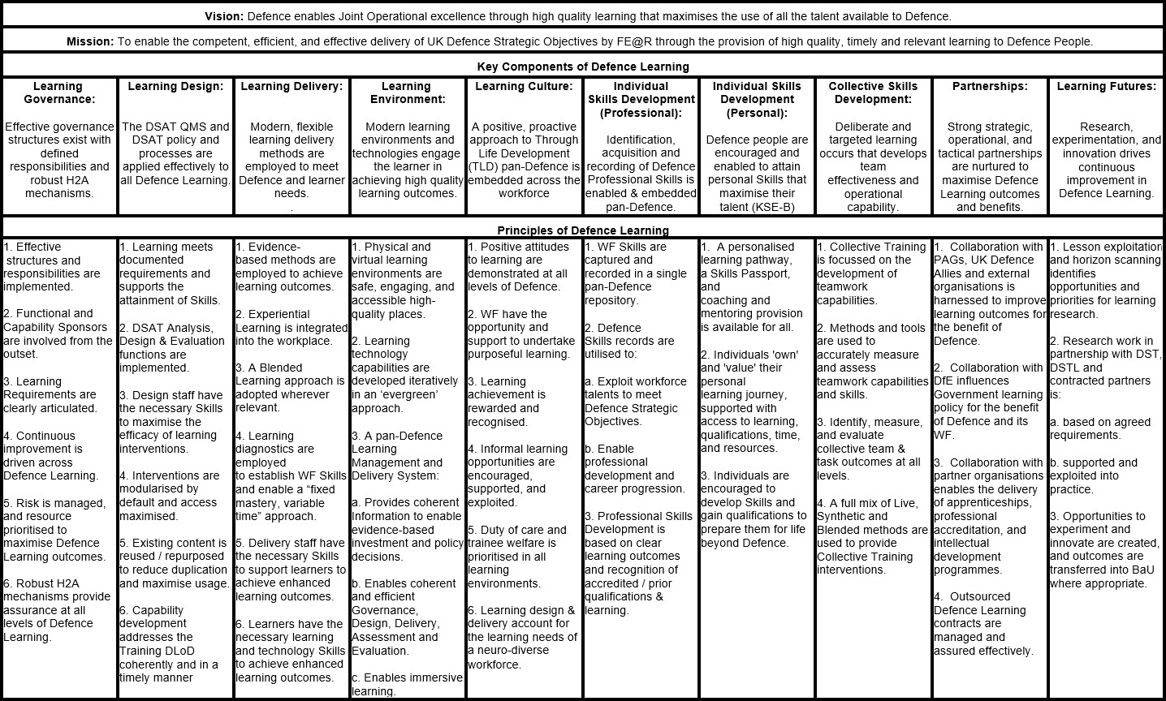

## The Defence Direction on the Defence Systems Approach to Training

## Introduction

* + 1. The Defence Systems Approach to Training (DSAT) process comprises activities relating to the analysis, design, delivery, and assurance of all Defence training, both individual and collective, across the Whole Force**6**. Integral to these four Elements is the need to ensure that the DSAT process is properly managed and governed. These management and governance activities, along with the assurance activities themselves, combine together to create a Management of Training System (MTS).
    2. The purpose of these activities is to ensure that the training of our people contributes directly to Defence outputs and helps to mitigate risk inherent in conducting the training. When the analysis, design, and delivery Elements of DSAT are combined with a robust MTS, the result is a Training System that delivers training that meets the required DSAT Quality Management Standard (QMS) and is:
* **Safe**
* **Risk-focused**
* **Accountable**
* **Appropriate to the training need**
* **Cost-effective**

In the context of this JSP, ‘training’ encompasses any training, education, learning or development, both individual and collective, that is designed to meet the needs of a Training Requirements Authority.

## What is the DSAT Process

* + 1. DSAT is the process that must be used by those who are involved in the analysis, design, delivery, assurance, management, and governance of training across Defence. DSAT is designed to generate a Training System that empowers trainers7 to deliver safe, risk-focused, appropriate, effective, efficient, and accountable training to trainees8 and training audiences. When new or changed equipment, technology, tactics, techniques, or procedures are developed, or when new or

6 The Whole Force encompasses Regular and Reserve personnel, MOD Civil Servants and civilians, including the Ministry of Defence Police and contractors. It is noted that training sourced through the pan- Governmental ‘Civil Service Learning / Government Campus’ is not subject to DSAT. Any other Civil Service training must be compliant with DSAT.

7 I.e. those engaged in delivering formal training across Defence, for both individual and collective training.

8 I.e. those across Defence undergoing individual and collective training, and encompasses such terms as ‘recruit’, ‘student’, ‘learner’, ‘exercising troops’ etc. These and other terms continue to be used in the wider Defence training community, particularly in Phase 1, Phase 2 and collective training.

changed policy or legislation is brought in, the requirement for new or amended training must be examined. After initial analysis, it may be decided that training is not required. There could be a solution from any of the other Defence Lines of Development. If training is required, DSAT is merely a tool to deliver training that meets the needs of the TRA as well as the DSAT QMS mandated by Defence. DSAT is not a complicated process, but it is detailed and, therefore, to aid in its use, a process with 4 Elements has been designed to ask, or state:

* **Element 1**: **Analysis**. *What is the requirement; is a new or amended training activity needed; and, if so, what kind?*
* **Element 2**: **Design**. *What should the training activity look like; who will deliver it, and with what resources?*
* **Element 3**: **Delivery**. *The training activity is delivered.*
* **Element 4**: **Assurance**. *Is the training activity being delivered correctly and does it meet the requirement? Is the whole Training System fit for purpose?*

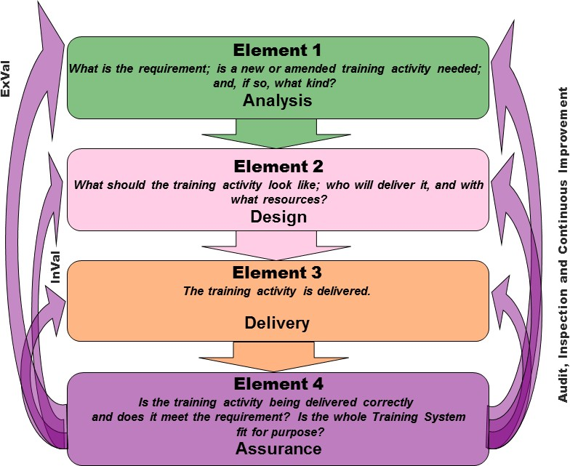

Figure 1: The Four Elements of DSAT9

* + 1. **DSAT, as illustrated in Figure 1, is not linear.** The process is iterative and assurance10 takes place regularly, and as part of all Elements. Whilst each of the DSAT Elements is mandated, the many activities that can be undertaken as part of each Element are not. This is because some training requirements are so simple that to complete all of the activities within each Element would be unnecessary and wasteful. The DSAT process is cyclical and flexible and should be applied intelligently rather than followed dogmatically. Users should select both the activities specific to their need and the order in which they are applied, to achieve the most appropriate Training System11.
    2. **Individual Training and Team/Collective Training.** The DSAT process must be applied to all individual and collective training pan-Defence and caters for both individual training and collective training needs. It has been designed to deliver

9 The colours chosen to differentiate between the 4 Elements in Figure 1 will be used throughout this JSP. Analysis activity is depicted in green; Design in pink; Delivery in orange and Assurance in purple.

10 Including Internal Validation (InVal), External Validation (ExVal), Audit, Inspection and Continuous Improvement.

11 Exceptions to the broad intent of the DSAT process, particularly where MTS and assurance activities are concerned, will require justification and risk management (if appropriate).

either one, or the other, or both. As individual training is part of, and a building block to, collective training, it is considered likely that trainees will conduct individual training activities, followed by collective training activities, as a ‘training continuum’ (see Figure 2) before they can be considered able to contribute effectively to Defence outputs.

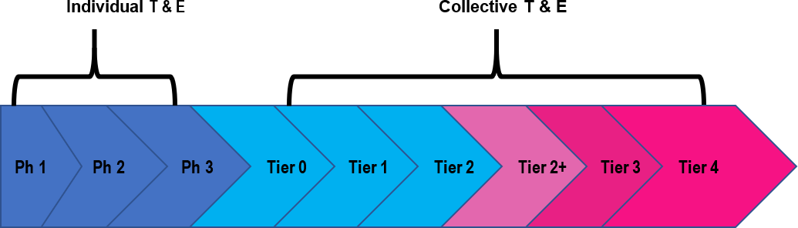

Figure 2: Training Continuum – Individual/Team/Collective

## What is the DSAT QMS?

* + 1. The DSAT Quality Management Standard (DSAT QMS) is the standard that is met when the outputs of the DSAT Elements and the MTS activities are delivered correctly, i.e. iaw JSP 822. DSAT assurance activity needs to focus on the mandated requirements of individual training (Volume 2) or collective training (Volume 3)*.*

## Roles

* + 1. **Main Stakeholders.** There are many different users of the DSAT process who are pivotal to ensuring the MTS is fulfilled. Detailed information on these roles can be found in Volume 2, Chapter 2 for Individual Training, and Volume 3, Chapter 2 for Collective Training. Key personnel or roles include:
* **Training Requirements Authority (TRA)**. The TRA represents the end-user of the trained output and is the ultimate authority for the derivation and maintenance of the Role/Team Performance Statement (Role/Team PS) and/or Framework.
* **Training Delivery Authority (TDA)**. The TDA is the organisation responsible for training delivery, but not always for the conduct of the actual training itself. It must be distinct from the TRA.
* **Training Provider (TP)**. The TP is the training school, college, organisation, establishment, unit, or group that delivers the training.
* **Other Stakeholders**. Whilst not directly involved in the process of generating training activities, there are other stakeholders who have an interest in the training provided and who will likely exert influence over the DSAT process in order to ensure that their needs are taken into account. These other stakeholders may include:
  + **Customer/Sponsor**12. Likely to be the Service or Joint Command, or the fielded force (units, ships or groups) who are tasked with delivering Defence effect and who need trained personnel to fulfil a wide variety of Roles.
  + **Defence Contractor**. Many training activities are carried out by Defence contractors, who are civilian personnel working for, and on behalf of, Defence.
  + **Training Audience**. Also known as Target Audience or Target Population, this is the group of individuals or Teams expected to be the recipients of the training solution.
  + **3rd Party Auditor or Inspector** (e.g. Ofsted 13 or a National Governing Body).
    - 1. **Roles in the Joint and Defence Environment**. The principles for the governance, management, and assurance of Joint/Defence training requirements are the same as for individual and collective training. However, the Joint and Defence training environment is complex. Direction on this can be found in Volume 2, Chapter 2 for Individual Training, and Volume 3, Chapter 2 for Collective Training.

## Contracting out Elements of the DSAT Process

* + 1. Where discrete elements of the DSAT process are outsourced to contractors, the exact requirement should be captured in the contract in order to ensure that DSAT activities that are undertaken by DSAT SQEP staff, are compliant with JSP 822 DSAT direction 14 . Outsourcing the provision of DSAT activity to commercial organisations can be an effective use of resources especially where capability or capacity shortfalls exist and where time imperatives or the need for concurrency demand it.

12 Individuals and organisations may consider themselves ‘Customers’ or ‘Sponsors’ of training but their requirements can only be represented by an identified TRA. TRAs are the only recognised ‘Customer’ at a CEB. Note also that Capability sponsors may own the T-DLoD through-life for a particular capability but usually handover the TRA role at an agreed point to an ‘in-service’ TRA.

13 Office for Standards in Education.

14 Existing contracts are not required to be amended to reflect the changes in terminology in this JSP. New contracts, or those undergoing significant contract amend, must reflect the changes.

## DSAT Processes within the Acquisition Process

* + 1. The Defence Acquisition System Operating Model defines how acquisition activities are to be conducted, including alignment to Finance and Military Capability (FinMilCap) and Service Command (SC) processes. Within this model sits the acquisition process of CADMID 15 and CADMIT 16 , which each Defence Line of Development (DLOD)17, including Training18, has to work within. Figure 3 describes how the training elements of capability fit within the CADMID/T lifecycle and what processes and outputs, including DSAT documentation, are required:
* **FINMILCAP Processes**. These financial planning processes ensure that pan- DLOD capabilities meet genuine needs, are affordable and compliant with Defence and SC policies and strategies. The cost of developing and delivering individual and collective training for new capabilities, as well as for updates and upgrades to existing, will be assured through the activities of the Personnel and Training DLODs engaging with capability sponsors and DE&S/ISS project teams. This includes developing through-life personnel and training costs within capability planning options, project initial and main gate business case cost models and project/in- service Procurement (P9) and Support (S9) funding lines*19*.
* **Concepts & Doctrine Processes**. Concept and doctrine documentation such as Concepts of Employment (CONEMP), Concepts of Use (CONUSE) and operational doctrine are integral parts of developing and delivering the right capabilities. Again, Personnel and Training DLODs must be considered in all these documents as they underpin the development of subsequent requirements documents. These concepts will be based on Defence and SCs’ policies and strategies for training.
* **Requirements Processes**. Within the Concept and Assessment phases of DE&S/ISS projects a User Requirement Document (URD) 20 and a System Requirement Document (SRD)21 are developed to enable the contracting of industry to deliver equipment and services. Within the Personnel and Training DLODs, DSAT Analysis processes can be used and documented to provide evidence in support of requirements for interim22 and steady state training solutions. This DSAT

15 Concept, Assessment, Demonstration, Manufacture, In-Service, Disposal. https[://www.k](http://www.kid.mod.uk/maincontent/cadmid_content.htm)id[.mod.u](http://www.kid.mod.uk/maincontent/cadmid_content.htm)k[/maincontent/cadmid_content.htm](http://www.kid.mod.uk/maincontent/cadmid_content.htm)

16 Concept, Assessment, Demonstration, Migration, In-Service, Termination. https[://www.k](http://www.kid.mod.uk/maincontent/cadmit_content.htm)id[.mod.u](http://www.kid.mod.uk/maincontent/cadmit_content.htm)k[/maincontent/cadmit_content.htm](http://www.kid.mod.uk/maincontent/cadmit_content.htm)

17 https://modgovuk.sharepoint.com/sites/DOM/SitePages/bGEN006.aspx

18 https://modgovuk.sharepoint.com/sites/DOM/SitePages/bGEN008.aspx

19 Note the Apache Programme example where the T-DLOD caused delays in delivering the capability: https://publications.parliament.uk/pa/cm200203/cmselect/cmpubacc/533/53303.htm.

20 https[://www.k](http://www.kid.mod.uk/maincontent/business/randa/content/urdprinciples.htm)i[d.m](http://www.kid.mod.uk/maincontent/business/randa/content/urdprinciples.htm)o[d.u](http://www.kid.mod.uk/maincontent/business/randa/content/urdprinciples.htm)k[/maincontent/business/randa/content/urdprinciples.htm](http://www.kid.mod.uk/maincontent/business/randa/content/urdprinciples.htm)

21 https[://www.k](http://www.kid.mod.uk/maincontent/business/randa/content/srdprinciples.htm)i[d.m](http://www.kid.mod.uk/maincontent/business/randa/content/srdprinciples.htm)o[d.u](http://www.kid.mod.uk/maincontent/business/randa/content/srdprinciples.htm)k[/maincontent/business/randa/content/srdprinciples.htm](http://www.kid.mod.uk/maincontent/business/randa/content/srdprinciples.htm)

22 When bringing into service new capabilities, training may be required before the formal in-service phase and hence interim training will be used to enable sufficient knowledge transfer to conduct trials & acceptance activities, doctrine development and train the trainers and training developers. Interim training

Analysis will subsequently go forward to update in-service SOTRs and Performance Statements for both individual and collective training. Following the acceptance by the Department of recommendations in a National Audit Office report 23 it is mandated that where the provision of training is proposed, the business case is to be supported by DSAT Analysis.

* **Deliver Processes**. Within the Demonstration to Manufacture/Migration phases, capability solutions are contracted, developed, and delivered into service. During these phases training solutions will also be procured and/or legacy training systems will be updated to reflect the capability changes. Where new solutions are needed, requirements processes may have to be followed again to develop URD, SRD, Integrated Test Evaluation & Acceptance Plan (ITEAP) and Through-Life Management Plan (TLMP), as well as the new DSAT training design and delivery documentation. Where training systems are being updated, these documents should already exist (if not created) and be updated accordingly to reflect the capability changes. Once training solutions are in place, steady state training can commence in accordance with normal DSAT processes.

does not have to comply with DSAT requirements due to its temporary nature and off-the-shelf availability but contracting against specific DSAT processes may provide opportunities to de-risk steady-state training development.

23 https[://www.n](http://www.nao.org.uk/reports/ministry-of-defence-use-of-simulators-in-training-2/)ao.[org.uk/reports/ministry-of-defence-use-of-simulators-in-training-2/.](http://www.nao.org.uk/reports/ministry-of-defence-use-of-simulators-in-training-2/)

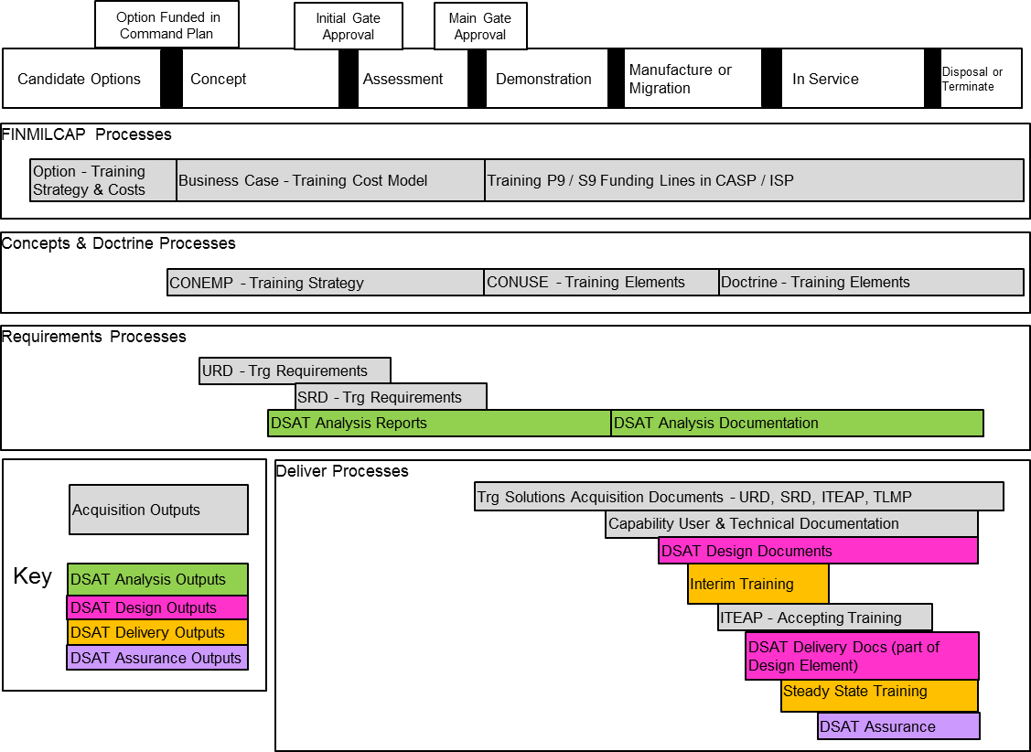

Figure 3: DSAT Processes within the Acquisition System

## DSAT and the Management of Risk

* + 1. **DSAT and the Management of Risk**. In the context of limited resources and time, Customers, Training Requirements Authorities (TRAs), Training Delivery Authorities (TDAs) and Training Providers (TPs) must apply DSAT intelligently, and thereby own and manage the inherent risks that arise; they must comply with DSAT policy **or** explain why they are unable to do so and how they have mitigated the consequent risks. DSAT, applied intelligently, manages, and mitigates the risks inherent in the requirement setting, design, delivery and assurance of Individual and Collective Training.

## Applying a ‘One Defence Mindset’ to DSAT

* + 1. A 'One Defence Mindset' is one where everyone works together to achieve Defence goals. This is respectful of the cultures and loyalties which exist across Defence but asks for us to approach the delivery of the Command Paper, in an integrated way and working as a wider Defence team. Recognising that when we work together, we are stronger than the sum of our parts.
    2. A ‘One Defence Mindset’ reduces the chance of mistakes and supports innovation because we consider the wider impacts of our actions. This could mean considering how our actions affect other parts of Defence, identifying how other parts of Defence can help us, and speaking with our colleagues to gather their views.
    3. It is therefore important, that whilst following the DSAT process, it should be followed with a ‘One Defence Mindset’.
    4. More information on the ‘One Defence Mindset’ can be [found here](https://modgovuk.sharepoint.com/sites/intranet/SitePages/One-Defence-Mindset.aspx)

## The Defence Direction on Management of Training System

## Introduction

* + 1. This chapter of the JSP outlines the Defence Direction relating to Management of Training System (MTS), further detailed direction on MTS can be found in Volume 2 (Individual Training) and Volume 3 (Collective Training). It will also explain the purpose of the DSAT QMS and how a robust MTS will assist in meeting that standard.

## What is MTS?

* + 1. Integral to the 4 Elements of analysis, design, delivery and assurance is the need to ensure that the DSAT process and the resultant Training System is properly **governed** and **managed** and meets the high standards required for training in Defence. The governance, management, and assurance (Element 4) of training are collectively known as an MTS. An MTS is an iterative mechanism (supported by documented products and processes) to ensure that the training being delivered remains meaningful and continues to contribute to delivering Defence effect. When delivered correctly, the outputs of the DSAT Elements, combined with the MTS, deliver a Training System that meets the required QMS.
    2. For the MTS to be effective, bodies such as boards and working groups must be established to ensure that the DSAT process remains on track and the Training System remains appropriate to the need. Key DSAT documentation (explained later in this Section) must also be produced. As an integral part of the MTS, activities that directly contribute to meeting the QMS are also embedded within each Element. The MTS mostly draws in products from the DSAT process in order to record and demonstrate that the QMS is being met and avoid duplication. All stakeholders in the Training System will have some involvement in the MTS.

## What is a Training System?

* + 1. A Training System, therefore, comprises the analysis, design and delivery of training along with the governance, management and assurance activities. Put another way:

DSAT 4 Elements **+** governance and management **=** Training System

* + 1. When conducted correctly, the Training System delivers training that meets the DSAT QMS mandated by Defence. Figure 4 shows DSAT and MTS activities combining to generate a Training System.

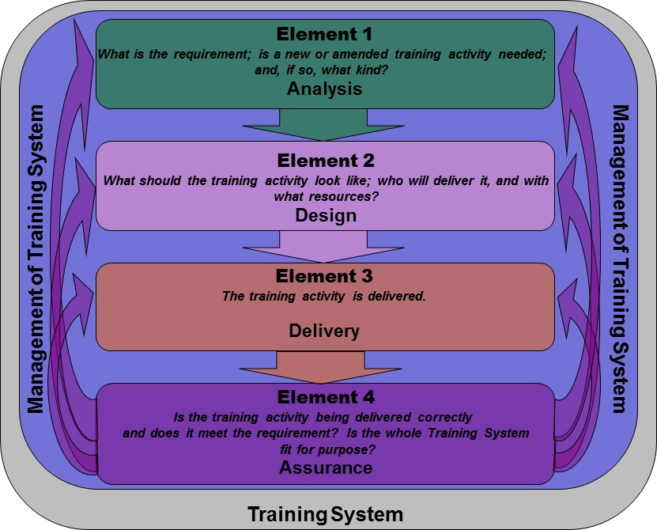

Figure 4: The DSAT Process Generating a Training System

* + 1. Defence requires its people to place themselves in harm’s way to deliver Defence effect. Defence people work in hazardous environments, under stressful conditions whilst conducting activities that carry a high risk to personal safety. Consequently, Defence must ensure that its Training Systems meet the very highest standards. Training must also be robust, realistic, and challenging if it is to prepare its personnel for the full spectrum of Defence Roles. However, there is a tendency, because of the risk, for Defence training organisations to provide more training than necessary in the misguided belief that this will make up for future uncertainties. And, in some cases, poorly designed or executed Training Systems can deliver insufficient training. The ideal then is a Training System that is designed to train its personnel to an optimal level so that they are equipped with the appropriate Knowledge, Skills, and Attitudes (KSA). Providing too much training costs money that will likely be taken from elsewhere in the training budget that could then result in insufficient training in other areas, which risks lives. Therefore, a Training System designed using a common process and that is governed and managed in accordance with the Defence mandated QMS, is vital to ensure that Defence people are best equipped to achieve Defence effect.

## Training Governance Activities

* + 1. **People Leadership Team (PLT) (5.16)**. This is a 3*/ 2* Defence level Board that is chaired by the Chief of Defence People (CDP). It is the highest-level governance body for training issues. Amongst other objectives, the PLT manages training strategic performance and risks, and provides the governance and management of Defence Training and Education.
    2. **Talent, Skills, Learning and Development Policy and Assurance Group (TSLD PAG) (5.18)**. This is a 1* Defence level group chaired by Hd TSLD and provides strategic Direction on Defence Training, Education, Skills, Recruiting and Resettlement matters. It is the principal forum for the governance and assurance of such activities throughout Defence.
    3. **Customer Executive Board (CEB) (5.19)**. For all training, CEBs form part of the MTS and are specific to the needs of that Training System. The general purpose of a CEB is to provide a mechanism for stakeholders to develop the scale and content of training to match the required Defence outputs within the available resources, and in accordance with relevant Defence and sS policies.
    4. **Working groups/steering groups (WGs/SGs) (5.20)**. There are several standing Defence level WGs and SGs that assist with policy, assurance, and governance of training across Defence.
    5. Collective Training has an additional governance structure that sits outside of the structure mentioned above, detail on this structure is set out in Volume 3 of this JSP.
    6. **Governance of Joint and Defence Training Requirements.** In all instances, a CEB is to be formed as early as possible in the process to manage, govern and assure Joint and Defence training requirements. In many cases the roles are already agreed but where the nomination of Lead TRAs, TDAs and Training Providers cannot be agreed between Service/Joint Commands, this is to be referred to the TSLD PAG for resolution. The matrix of Lead TRAs and Lead TDAs for training in Joint and Defence training environments is held on the [Training](https://modgovuk.sharepoint.com/sites/people-tesrr-policy/TRAHub/Lists/TRA%20Database/AllItems.aspx?as=json) [Requirements Authority Hub](https://modgovuk.sharepoint.com/sites/people-tesrr-policy/TRAHub/Lists/TRA%20Database/AllItems.aspx?as=json). It is the responsibility of SCs to keep this matrix up to date.

## Defence Direction on the Safe System of Training

* In addition to the requirement for a Safe System of Work, a Safe System of Training (SST) **must** be employed within all training environments. A SST comprises of 4 key elements which Commanders and line managers **must** understand:
  + Safe Persons
  + Safe Equipment
  + Safe Place
  + Safe Practice
* This Direction applies to all Defence training.
* Commanders and managers **must**:
  + ensure that all personnel in the training environment are provided with the appropriate information, instruction, and supervision.
  + ensure that trainers and supervisors are competent and given an appropriate level of supervision to ensure that the delivery of training is appropriate to the ability of those being trained.
  + ensure correct equipment is available, operated and maintained by competent and appropriately supervised individuals and associated training and maintenance records are kept.
  + ensure that all risks have been assessed, recorded, and mitigated as far as reasonably practicable.
  + ensure that all personnel are fully briefed on all necessary controls to be implemented.
  + ensure that training practices be conducted strictly in accordance with drills, procedures and instructions and direction.
  + identify, manage, record, and escalate cumulative risk.
  + Ensure any change to training where the resultant risk has an impact on Safety that increases risk to life and could result in death or serious injury must be subject to an approved risk assessment by the Commander, Line Manager, or accountable person.
* Trainees **must** adhere to any instructions delivered before and/or during the training.

## Introduction

* + 1. Nothing in this chapter obviates the responsibilities of Commanders and those responsible for training to follow the direction and guidance set out in JSP375 for the Safe System of Work (SSW). The Safe System of Training (SST) does not replace Health and Safety legislation, nor the guidance offered by the Health and Safety Executive; rather, the SST should be read in conjunction with JSP375. The SST is derived from the Safe System of Work (SSW) and sets the conditions under which Defence training is to be conducted, ensuring personnel are provided with the appropriate information, instruction, and supervision. This enables Defence to meet the training imperative set by the Operational Requirement, whilst ensuring that personnel given the best possible preparation for the roles they may undertake. The SST enables Defence to maintain training risks at As Low As Reasonably Practicable (ALARP) by ensuring those who conduct the training are competent and that all risks, and associated mitigation measures have been considered. Further direction and guidance on SST policy is being developed and will be published as soon as practical.
    2. The SST differs from the SSoW as those undergoing training cannot be deemed competent until they have successfully completed training and have undertaken any required assessments, achieved qualifications, **and** have obtained the currency and experience24 to perform their duties*.* The SST is important as training units carry additional risk as many of their people, including staff, have not yet reached a specified level of competence. Commanders and Managers have the additional responsibility to ensure those in their charge can deliver and train safely. Training supervisors and deliverers must ensure that the training risks are recognised, communicated, and mitigated, and in conjunction with those in support of training, dynamically alter training as necessary. The SST sets the conditions under which training is to be conducted, ensuring those undergoing training are given appropriate information, instruction, and supervision.
    3. The levels of supervision and competency required of those delivering and supervising training will be directed by the relevant Training Authority.
    4. Trainees are to be fully briefed on all hazards they will face during training and **must**

adhere to any instructions delivered before and/or during the training.

24Where experience is practice that might leave some residual KSAs. Currency is whether those KSAs are still relevant and/or meet an accepted standard that enable competent, safe and legal performance*.*

## The 4 Elements of SST

* + 1. A SST comprises of the 4 same elements as the SSoW (safe persons, safe equipment, safe place and safe practices) but contextualised with additional considerations / training elements:

## Safe Persons

* + - 1. There are 3 categories of people at risk in training:
         * Personnel undergoing training and those personnel delivering it.
         * Personnel including civilian staff and contractors in support of training.
         * General public including those unaware of the military training activity and including any unauthorised individuals25.
      2. Commanders or line managers **must** ensure that trainers and those supervising the training are competent and given an appropriate level of supervision.
      3. Training **must** be at a level commensurate with the capability of the participants.

## Safe Equipment

* + - 1. Any equipment including explosives and ammunition, brought into service following the Defence process for the production of a Safety Case, should have appropriate documentation defining the safe operation and maintenance of the equipment under service conditions.
      2. Commanders or where delegated, line managers **must** ensure their subordinates have available, and make proper use of, the correct equipment to carry out an activity in accordance with the appropriate Service Equipment Support Publications or similar set of instructions. They **must** ensure that only competent persons or those under appropriately supervised training are allowed to operate and/or maintain the equipment and the associated completed training and maintenance records are kept.

25 Any individual deemed to be trespassing or in an unauthorised location.

## Safe Place

* + - 1. A place in which the controls, necessary to enable authorised training to be conducted safely, **must** have been identified by a site-specific risk assessment and directed through appropriate Standing Orders, such as Range Standing Orders.
      2. Commanders or line managers **must** ensure both trainers and those personnel under training are fully briefed on all necessary controls to be implemented in order to maintain the Safe Place.

## Safe Practices

* + - 1. Safe Practice includes the following of correct procedures, the provision of effective supervision and delivery of effective training, the briefings of all warnings, cautions and controls together with the use of appropriate Personal Protective Equipment (PPE).
      2. Practices **must** be conducted strictly in accordance with drills, procedures and instructions laid down by the Service authorities. These drills and procedures, taking into account the training imperative, are identified in the Safety Case and developed in accordance with the Defence Systems Approach to Training (DSAT). Training is only to be delivered by a qualified and competent person to ensure that procedures are strictly adhered to, and such instruction and training is closely supervised by the Chain of Command to ensure Safe Practice is implemented.
      3. All training must be monitored and/or supervised by a competent person to ensure that all procedures are adhered to and that safe working practices are maintained.
      4. Risks and control measures associated with the practice must be communicated to all participants.

## Risk Management

* + - 1. There are well established processes (JSP 375) and (JSP 892) for determining and assessing risks in place. In addition to Health and Safety requirements set out in (JSP 375). There is also a requirement for the Commanders Risk Assessment (CRA) pertaining to the care and welfare of trainees (Further information on the CRA can be found in volume 4).
      2. Risk/assumption management must start at the beginning of the DSAT process26. Risks/assumptions are to be held on risk/assumption registers at all levels (e.g. training establishment, SC or SC’s subordinate training HQ) and are to be managed iaw relevant Defence risk management policies. Risks/assumptions must be reviewed regularly during all Elements of the DSAT process and updated with any new and emerging risks.
      3. Training should be delivered as it was planned, with the correct training facilities, suitably qualified and experienced training staff and with the correct procedures and instructions. Undue pressure should not be put on managers or those delivering training to deviate from planned and endorsed training programmes. Those responsible for the management and delivery of training should have the ability to amend training as necessary, to meet changing environmental conditions (e.g. avoiding excessive heat), equipment deficiencies or shortfalls in resources. However, careful consideration must be given to the resultant risk, especially where it has an impact on safety that increases the risk to life and could result in death or serious injury. It is imperative that the delivery of training remains progressive and subject to a safe system of training throughout. Changes to planned training delivery such as truncating, accelerating or other variations (changing location, time, or content etc) can affect the rate at which training proficiency is achieved, potentially increasing the associated risk. In many cases certain proficiency criteria must be met by trainees to be able to perform tasks in a consistent, reliable, and repeatable manner that meets established standards, facilitating the progression in training and enabling post training activities. This is of paramount importance for any critical training which, if not conducted to the correct standard, increases the risk to life and could result in death or serious injury. Any change to the content, time, or resources available for such critical training **must** be subject to an approved risk assessment by the Commander, Line Manager or accountable person.
      4. Furthermore, for all training activities, dynamic risk assessments are to be conducted before or during activities in response to changing or unexpected conditions. This will allow training to be paused, amended, or stopped as necessary.

26 See JSP 892 for Defence Risk Management Policy.

## Cumulative Risk

* + - 1. It is not sufficient to merely monitor risks, but all involved must be aware of the possibility and impact of cumulative risk. This may occur within a training day or training course as activities are changed and amended, with the trainer or supervisor required to keep track of the impact on safety as well as the training standard and welfare of all those involved. Cumulative risk incorporates other areas such as support and management, where there is no longer the capacity to maintain the existing training or update it to meet changing requirements (e.g. input standards) or fully implement the recommendations from reviews. For example, the informal act of a changing task (change in task complexity, omitting a particular step, changing the conditions set out in the planned activity) - although necessary, may have introduced additional risks that were not recognised- either in facilitating training, or in the need for suitable progression for the trainees. In addition, gapping in the training support area may mean this change is never updated in the DSAT mandated documentation and hence it is not reviewed and authorised. Operational pressures and resource constraints may then mean this shortfall is continually repeated in several areas and informal changes become normalised: the training delivered may be required but does not match the authorised and documented instructions and procedures being managed and resourced. Such cumulative risk must be recognised, escalated through the chain of command, and actioned as necessary.

## Assurance

* + - 1. Assuring against the Safe System of Training is not mandated, and those involved in Assurance activities must follow the direction given in Volume 5 of this JSP. However, the Safe System of Training is useful reference for Auditors.

## Document Information

## Document Coverage

The contents of this policy supersede all previous MOD Policy on the same subject(s).

## Document Information

|  |  |
| --- | --- |
| Filename: | Introduction |
| Document ID: | JSP 822, Volume 1 |
| Owning Function / Team: | Talent, Skills, Learning and Development |
| Service Owner (1*): | People-TSLD-Hd OF6 |
| Approving Authority: | 1* TSLD Policy Assurance Group (TSLD PAG) |

## Document Versions

|  |  |  |
| --- | --- | --- |
| Version | Pub. Date | Revised pages |
| 3.0 | February 2024 | [Press here](https://modgovuk.sharepoint.com/sites/people-tesrr-policy/JSP822/Amendments%20Record/SitePages/JSP-822-V7.0%2C-Volume-1-V3.0.aspx) |
| 2.0 | October 2023 | [Press here](https://modgovuk.sharepoint.com/sites/people-tesrr-policy/JSP822/Amendments%20Record/SitePages/JSP-822-V6.0%2C-Volume-1-V2.0.aspx) |
| 1.0 | September 2022 | [Press here](https://modgovuk.sharepoint.com/sites/people-tesrr-policy/JSP822/Amendments%20Record/SitePages/JSP-822-V5.0%2C-Volume-1-V1.0.aspx) |

MOD will review this Policy in three years, or when changes to legislation or best practice dictates.

## Linked JSPs

|  |  |
| --- | --- |
| JSP Number | JSP Name |
| [345](https://modgovuk.sharepoint.com/sites/IntranetHeadOffice/SitePages/JSP-345.aspx) | Applying Prevent within Defence |
| [375](https://modgovuk.sharepoint.com/sites/IntranetHeadOffice/SitePages/JSP-375.aspx) | Management of Health and Safety in Defence - especially Chapter 42: Cold Injury Prevention and Chapter 41: Heat Illness Prevention |
| [381](https://modgovuk.sharepoint.com/sites/IntranetUKStratCom/SitePages/Joint-Service-Publication-381-Aide-Memoire-on-the-Law-of-Armed-Conflict.aspx) | Aide-Memoire on the Law of Armed Conflict |
| [383](https://modgovuk.sharepoint.com/sites/IntranetUKStratCom/SitePages/jsp-383-law-of-armed-conflict.aspx) | Joint Service Manual on the Law of Armed Conflict |
| [398](https://modgovuk.sharepoint.com/sites/defnet/HOCS/Pages/JSP398.aspx) | United Kingdom Manual of National Rules of Engagement |
| [418](https://modgovuk.sharepoint.com/sites/IntranetHeadOffice/SitePages/JSP-418.aspx) | Management of Environmental Protection in Defence |
| [419](https://modgovuk.sharepoint.com/sites/IntranetHeadOffice/SitePages/JSP-419.aspx) | Adventurous Training in the UK Armed Forces |
| [440](https://modgovuk.sharepoint.com/sites/IntranetHeadOffice/SitePages/JSP-440.aspx) | Defence Manual of Security and Resilience |
| [441](https://jsp441.r.mil.uk/index.php/JSP_441) | Information, Knowledge, Digital and Data in Defence |
| [456](https://modgovuk.sharepoint.com/sites/IntranetUKStratCom/SitePages/JSP456.aspx) | Defence Catering Manual |
| [462](https://modgovuk.sharepoint.com/sites/IntranetFinanceHub/SitePages/JSP-462-Financial-Management-and-Charging-Policy-Manual(1).aspx) | Financial Management and Charging Policy Manual |
| [507](https://modgovuk.sharepoint.com/sites/IntranetFinanceHub/SitePages/JSP-507.aspx) | Investment Appraisal and Evaluation |
| [534](https://modgovuk.sharepoint.com/sites/IntranetHeadOffice/SitePages/JSP-534.aspx) | The Tri-Service Resettlement and Employment Support Manual |
| [567](https://modgovuk.sharepoint.com/sites/IntranetHeadOffice/SitePages/JSP-567.aspx) | Contractor Support to Operations (CSO) |
| [604](http://jsp604.r.mil.uk/) | Defence Manual of Information and Communication Technology (ICT) |
| [740](https://modgovuk.sharepoint.com/sites/IntranetDefenceDigital/SitePages/jsp-740.aspx) | Acceptable Use Policy (AUP) for Information and Communications Technology (ICT) |
| [752](https://modgovuk.sharepoint.com/sites/defnet/HOCS/Pages/Armed-Forces-Allowances-and-Expenses.aspx) | Tri-Service Regulations for Expenses and Allowances |
| [757](https://modgovuk.sharepoint.com/sites/IntranetHeadOffice/SitePages/JSP-757.aspx) | Tri-Service Appraisal Reporting Instructions |
| [763](https://modgovuk.sharepoint.com/sites/IntranetHeadOffice/SitePages/JSP-763.aspx) | The MOD Bullying and Harassment Complaints Procedures |
| [765](https://modgovuk.sharepoint.com/sites/defnet/HOCS/Pages/JSP765.aspx) | Armed Forces Compensation Scheme - Statement of Policy |
| [770](https://modgovuk.sharepoint.com/sites/IntranetHeadOffice/SitePages/JSP-770.aspx) | Tri-Service Operational and Non-Operational Welfare Policy |
| [794](https://modgovuk.sharepoint.com/sites/IntranetHeadOffice/SitePages/JSP-794.aspx) | Defence Policy for Administration of Personal and Professional Development (AP&PD) on JPA |
| [830](https://modgovuk.sharepoint.com/sites/defnet/HOCS/Pages/JSP830.aspx) | Manual of Service Law |
| [831](https://modgovuk.sharepoint.com/sites/IntranetHeadOffice/SitePages/JSP-831.aspx) | Redress of Individual Grievances: Service Complaints |
| [833](https://modgovuk.sharepoint.com/sites/defnet/HOCS/Pages/JSP833.aspx) | Minor Administrative Action |
| [834](https://modgovuk.sharepoint.com/sites/IntranetHeadOffice/SitePages/JSP-834.aspx) | Safeguarding |
| [835](https://modgovuk.sharepoint.com/sites/IntranetHeadOffice/SitePages/JSP-835.aspx) | Alcohol and Substance Misuse and Testing |
| [887](https://modgovuk.sharepoint.com/sites/IntranetHeadOffice/SitePages/JSP-887.aspx) | Diversity, Inclusion and Social Conduct |
| [892](https://modgovuk.sharepoint.com/sites/IntranetHeadOffice/SitePages/JSP-892.aspx) | Risk Management |
| [893](https://modgovuk.sharepoint.com/sites/IntranetHeadOffice/SitePages/JSP-893.aspx) | Procedure for personnel and posts which require a disclosure check |
| [906](https://modgovuk.sharepoint.com/sites/defnet/HOCS/Pages/JSP906.aspx) | Defence Principles for Coherent Capability |
| [912](https://modgovuk.sharepoint.com/sites/defnet/HOCS/Pages/JSP912.aspx) | Human Factors Integration for Defence Systems |
| [939](https://modgovuk.sharepoint.com/sites/IntranetHeadOffice/SitePages/JSP-939.aspx) | Defence Policy for Modelling and Simulation (M&S) |
| [950](https://modgovuk.sharepoint.com/sites/IntranetUKStratCom/SitePages/JSP-950--Medical-Policy.aspx) | Medical Policy |

## Applicability

The policy contained in this Volume applies to the Whole Force which encompasses Regular and Reserve personnel27, MOD Civil Servants, and civilians, including the Ministry of Defence Police and contractors. It is noted that training sourced through the pan- Governmental ‘Civil Service Learning / Government Campus’ is not subject to the policies in this document. Any other Civil Service training must be compliant with the policies in this document.

The policy in this document does not apply to training deemed ‘Informal’ or ‘On-the-Job’.

Organisational Learning is captured under the Defence Organisational Learning Strategy (DOLS) Framework owned by Joint Warfare in UKStratCom and is not within the scope of JSP 822.

## Diversity and Inclusion

MOD respects and values people of all backgrounds. The Individual Training policy is designed to ensure all employees are treated in a fair, transparent, and consistent manner. All those involved in the management of MOD employees must abide by legislation and should adhere to MOD policy.

For more information on diversity and inclusion, please see the [MOD Diversity & Inclusion](https://modgovuk.sharepoint.com/sites/IntranetDiversityAndInclusion) [Pages](https://modgovuk.sharepoint.com/sites/IntranetDiversityAndInclusion) on MODnet.

This policy has been subject to an Equality Impact Assessment (EA).

|  |  |  |
| --- | --- | --- |
| Document | Date | Owner |
| [Equality Assessment](https://modgovuk.sharepoint.com/sites/people-tesrr-policy/SitePages/Public-Sector-Equality-Duty-(PSED-the-Equality-Duty).aspx) | 05/02/2024 | People-TSLD-Trg Policy HEO |

## Glossary

The Glossary of Definitions, Terms and Acronyms can be found on the [Defence Training](https://modgovuk.sharepoint.com/sites/people-tesrr-policy/JSP822/SitePages/Glossary.aspx) [and Education Policy and Guidance](https://modgovuk.sharepoint.com/sites/people-tesrr-policy/JSP822/SitePages/Glossary.aspx) Sharepoint site.

27 This includes UTCs, and military personnel (Regular & FTRS) that instruct Cadets and CFAVs. This does not include non-military personnel that instruct Cadets and CFAVs.